Mar 14, 2025
Ref: IIH/MD/2025/03/014

Director, Sustainability
IHS Nigeria
Plot 934 Idejo Street
Off Adeola Odeku
Victoria Island
Lagos, Nigeria
Dear Ma,

REQUEST FOR PAYMENT DISBURSEMENT TO PURCHASE ADDITIONAL ART HACKATHON ARTWORK

I write to formally request the disbursement of N250,000 each to the listed beneficiaries below, for purchase of their artwork entered at the recently concluded Art Hackathon hosted at the Ilorin Innovation Hub. Kindly find below the payment details for the winners:
Artist Name | Bank Name | Account Number | Phone Number
Michael Olayimika Iyowu | Polaris Bank | 3017706364 | 07037002243
Ifebajo Stephen Okikioluwa | Access Bank | 0092732806 | 09030972639
Kabir Isah | United Bank For Africa | 2077368937 | 08132421562
Solomon Okeuhie | Access Bank | 1896985482 | 07033621757
Oluremi David James | Gtbank | 0261958004 | 09022353707
Yusuf Abdullateef Oluwabukola | Opay | 8145754155 | 09137209731
Ifeanyi Ifemeje Kingsley | Gtbank | 0033332162 | 07068629760
Yusuf Abdullateef Oluwabukola | Opay | 8145754155 | 09137209731
Alani Timilehin Oluwafikayomi | Moniepoint Business Banking | 8061428697 | 08061428697
Endurance Otamayomi Oye | Opay | 8108998216 | 08108998216

Yours sincerely,
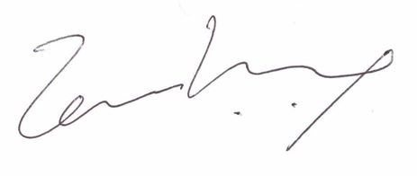
Temi Kolawole
Managing Director

